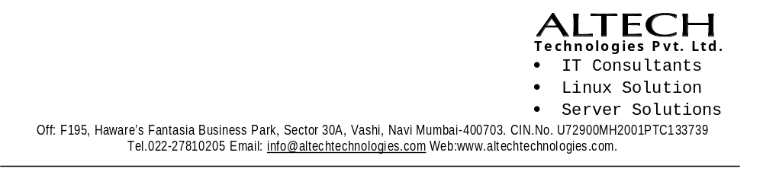

Offer letter
To,
Mr. Obaidurrahman Abdul Razzaque.
Mahada plot No 144, Noor Bagh, Malegaon Dist. Nashik.

With reference to your application and subsequent interview with us, we are pleased to offer you the following position:

Position | Trainee Developer
Probation | 3 months
Salary | Rs 12,000 per month
Joining Date | 19th December 2022

On successful completion of probation period, you will be confirmed in the service and given the following position:

Position | Salary | Period
Junior Developer | Rs 15,000 per month | 4th – 15th month
 | Rs 20,000 per month | 16th – 27th month

On reporting, please bring two recent passport size photographs, Original and photocopy of all educational certificates, proof of age certificate, IT Declaration, last employer’s salary certificate/Pay Slip and relieving letter of the last employer if any.

Please return a signed copy of this letter as a token of your acceptance of the offer, confirming your date of joining.
We look forward to a mutually rewarding relationship.

Yours faithfully
Accepted & Agreed

Sing:…………………..
Name:
For Altech Technologies Pvt Ltd.

Allauddin. R Date :
( Director) Sign:

